
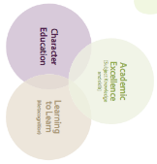

Brixham C of E Primary Long Term Planner Year 1

Autumn 1 |  |  | Autumn 2 |  | Spring 1 |  |  | Spring 2 |  | Summer 1 |  | Summer 2
Citizenship  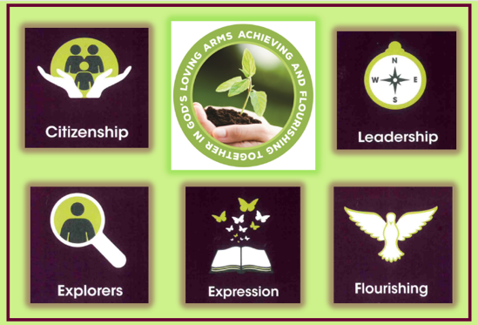 |  |  | Leadership  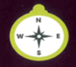 |  |   Exploration |  |  |   Expression |  | Flourishing  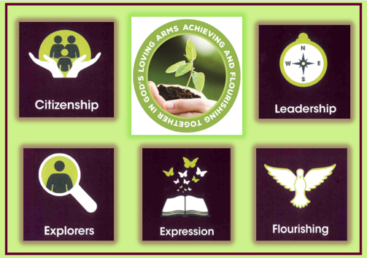 |  | Citizenship  
Year Group Key Knowledge and Skills
History | Narrative  3 weeks | DT  1 week | Science  3 weeks | Geography  3 weeks | World Views  2 weeks | Art  2 weeks | Narrative  2 weeks | History  3 weeks | Science  3 weeks | Geography  2 weeks | Art  2 weeks | Science  3 weeks | RSE  2 days | DT  2 weeks
Changes in my lifetime  I know how to sequence an event from the time I was born to the present time.  I know changes that have happened in my lifetime. | Story with a theme of compassion.  I can describe a character and their feelings. | Cooking  I can accurqtely measure and weigh.  I can use simple cooking techniques. | Materials  I can compare and group materials together.  I can suggest the suitability of materials. | My locality and using a map  I know how to use a simple local map to identify different features.  I know what are man-made and natural features. | Treating people who are different with compassion  I can show care for others.  I know secuirty and love are important.  I know what makes a good friend and how to be a good friend. | Drawing and Painting-  I know what lines can be created using materials.  I can achieve dark and light tones. | Whole School writing experience  I can use a range of adjectives in my writing.  I can describe a setting and a character to make my writing more intriguing. | Significant individual  I can talk about someone that was important and give an account of their life. | Seasonal changes  I know the different weather paterns associated with each year.  I can identify a season.  I can identify signs that suggest the season is changing. | Contrasting localities  I know how to compare this locality to mine and identify how they meet the needs of the community.  I know how to give simple directions. | Sculpture  I know to join a range of materials.  I know how to shape different materials.  I know the difference between 2D and 3D shapes. | Plants and growing  I know how seeds and plants grow into plants and if it is healthy.  I know the impact that water, temperature and food have on plants. | Growing and changing  I know that families are different.  I know that families have different roles. | Make something that works  I can say how something works.  I can talk about my design
Key Enquiry Question
How have things changed in my lifetime? | How can I show compassion for a character in a story opening? | How can we use our skills to serve our community? | Which material makes the best bridge for the Billy Goats Gruff? | How does Brixham support us? | Why are differences so important? |  | How can we create a picture in our readers head? | Francis Drake – Hero or Pirate? | What changes do we notice throughout the year? | Why is London one of the most famous cities in the world? | How can I improve the school environment with sculpture? | What does a plant need to thrive? | Are all families the same? | How can I make the best catapult?
Writing Genre
Timeline | Narrative | Instructions | Letter | Infographic Page | Poem | Foam print self-portrait | Narrative | Diary entry | Weather forcast | Persuasive leaflet | Descriptive text | Information text |  | Science report
Teaching of Other Subjects
Religion and Worldviews – a core subject taught weekly Music- weekly lessons using the Kapow programme MFL-weekly lessons using the Kapow French Programme
PE/Games including swimming in KS2 taught weekly

